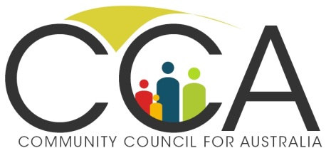**Media Release 11/10/12**

**If SA can do it, why not other states?**

Today’s announcement that the South Australian government will not require nationally registered charities to further establish their bona fides has been warmly welcomed, but some are questioning why other states are not offering the same level of support to charities. The not-for-profit sector employs more than one million Australians and turns over approximately $100 billion each year.

Rev Tim Costello, Chair of CCA and CEO of World Vision said, ***‘after decades of discussion, it is very pleasing to see the South Australian government joining the Federal government in showing some leadership to support the charitable sector. We commend this agreement between SA and the Federal government as part of the larger not-for-profit reform agenda.***’

According to David Crosbie, CCA CEO, ***‘the charities sector is drowning in a sea of red tape, duplication and compliance, mostly imposed by well-meaning but misguided bureaucracies at both a Federal and State government level. Today’s announcement shines some light at the end of the not-for-profit reform tunnel. Now if we can just get this train moving …’***

Toby Hall, CCA Board Director and CEO of Mission Australia said, ***‘great to see South Australia is leading the way with a common sense approach towards charity sector regulation that all states would be wise to follow. It will save time and money for both charities and governments.’***

Dr Stephen Judd, CCA Board Director and CEO of Hammond Care said, ‘***The Productivity Commission report into the charitable sector found unnecessary government compliance requirements are increasing, costing the sector millions of dollars in compliance. SA is to be commended for starting to reverse the trend so charities can focus more on their purpose, and less on red tape.’***

Dr Lisa O’Brien, CCA Board Director and CEO of The Smith Family said, ***‘Removing compliance costs for charities is always welcome, especially in areas like national fundraising requirements that create such an administrative nightmare for national organisations like The Smith Family.’***

Mr Crosbie questioned why other State and Territories were not joining with SA in supporting the not-for-profit sector? ***‘Governments around Australia talk about wanting to support the charitable sector by cutting red tape and reducing the compliance burden on not-for-profits, but these statements are usually just decorative policy words rather than a commitment to real action. The Federal and SA governments have backed up their rhetoric with action that will actually make a real difference to the sector. Other governments should get on board.’***

Legislation to establish the ACNC is currently before the Senate. The ACNC intends to introduce a ‘charities passport’ that establishes the bona fides of a charity. Currently, if charities want to run a national fundraiser or seek a payroll exemption, they have to register separately with each State.

**Contacts:** **David Crosbie 0419 624 420 Sarah Gavel 0413 494 010**